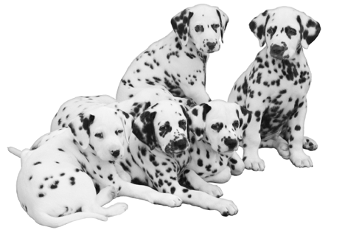
The Dalmatian or the “Dal,” as they are known worldwide, is an intelligent and affectionate breed, which means constant companionship, love and attention—often expressed by following you from room to room.

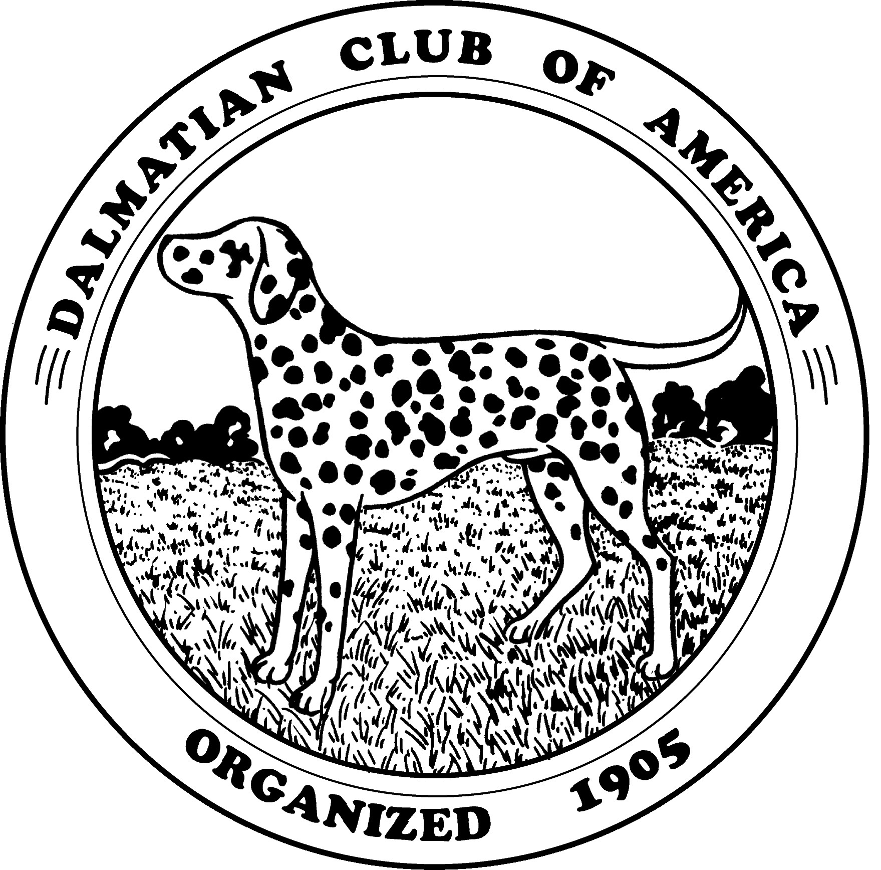
The Dalmatian Club of America is happy to provide you with some basic information about our breed’s physical characteristics, personality, care, health, and history. We hope it will help you develop a basic knowledge of these beautiful spotted dogs!

Physical Characteristics: The Dalmatian’s most unique physical feature is, of course, his spots which may be black or liver (brown). Dalmatians are medium in size, usually between nineteen to twenty-four inches when measured at the shoulder. Males and females vary in weight, but the most common range is forty to sixty pounds.

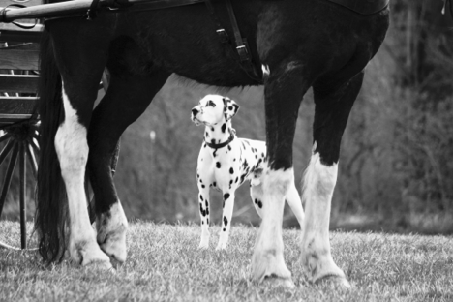
Personality: Of both sporting and working heritage, Dalmatians are well suited to be a family pet. They can also be eager participants in a wide variety of different performance events: agility, rally, barn hunt, lure coursing, dock diving, road trials with horses, scent work, tracking, and obedience. Some are certified therapy dogs. And every single one of them is dependable and sensible enough to let you know when your guests or the mailman arrives—even before the doorbell rings. The Dal does it all!

Dalmatians should be given basic training. They are intelligent and need a structured outlet for their busy brains. Often new owners begin training their puppy for good citizenship and end up happily involved in competition sports that the agile and intelligent Dalmatian enjoys so much. Socialization of young Dalmatians is very important. By exposing the puppy to new places, new faces and a variety of different experiences, he will be more settled and sociable, and a social Dal is a happy Dal—one who will be a true ambassador for the breed.

Grooming: Clean by nature, Dalmatians are one of the few breeds that groom themselves and have none of the odor common to other dogs. Even when you stroke their extremely soft coat, your hand will still smell fresh. Dals do shed year-round, but a little bit of regular brushing helps to minimize this. A bath three to four times a year is usually enough, and breeders discourage frequent bathing, as soap removes the natural oil that keeps the coat in good condition; in addition, a dry coat means an itchy coat. Toenails should be trimmed weekly. The condition of their teeth should be part of the annual checkup with the vet

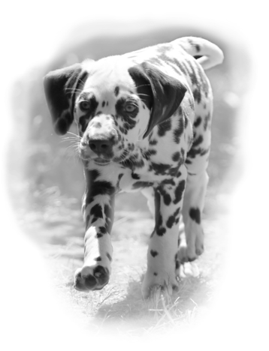
Health: Overall, Dalmatians are a healthy breed with few widespread common health concerns and a life expectancy of 11-15 years. All responsible breeders work toward genetic health for the breed, investigating potential sires and dams for sound temperaments, as well as testing hips, eyes, ears, and thyroid. Congenital deafness in one or both ears at birth is found in 11.5% of puppies according to the Orthopedic Foundation for Animals database. All responsible breeders conduct a B.A.E.R. hearing test on all their litters and provide the test results to new owner. The Dalmatian also has the genetic predisposition to develop bladder stones. Because “blockage” with a stone is potentially life threatening, it must be treated as an emergency. Proper (low purine) diet, plentiful clean water and frequent opportunities to urinate can limit the possibility of occurrence. We now know that reaching physical maturity before neutering is an important component in helping to prevent blockages, and The Dalmatian Club of America strongly urges waiting to spay/neuter until Dalmatians celebrate at least their first birthday. In addition, females (of any breed) spayed after their first season are less likely to develop mammary or uterine tumors.

History: No one knows for sure where Dalmatians originated, but there are Renaissance paintings showing Dalmatians in hunting scenes from Spain, Italy and France. There is also some evidence that they were popular with nomadic Gypsies in the 1400 and 1500’s used as both entertainment (trick dogs) and to guard property. Their heritage as coaching dogs began in England when the gentry, including Queen Elizabeth I, often had Dalmatians to accompany horse drawn carriages as both a status symbol and as guards for the coach’s passengers and their possessions. Their reputation as “fire dogs” dates back to the days of horse drawn fire wagons and is primarily a US phenomenon. The Dalmatian’s affinity for horses is instinctual and well known.

Learn More: If you think a Dalmatian may be the right fit for your family, please visit our website https://dalmatianclubofamerica.org for more information about Dalmatians. Please look for a reputable breeder who has health tested the parents, provided veterinary care to the mother and puppies, socialized the puppies, B.A.E.R. tested the puppies for hearing, is dedicated to preserving the integrity of the breed, and who will take the dog back at any time throughout its life if you are unable to keep it.

Thank you for visiting our Dalmatian booth! We hope you enjoyed meeting our spots!

